**Vim Reference Guide**

1. **i** command activates the --INSERT-- mode, which allows the file’s content to be edited.

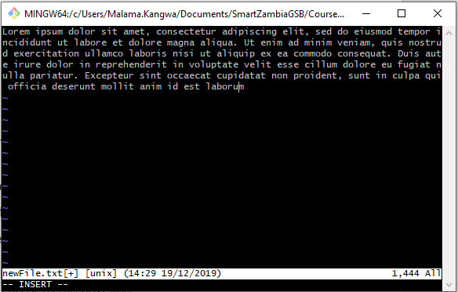

2.**Esc** command exits whatever mode the editor is and returns the editor to its command line.

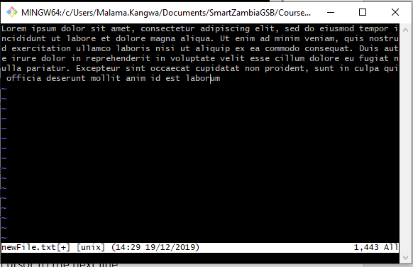

3.**:w** command save whatever changes have been made to the file.

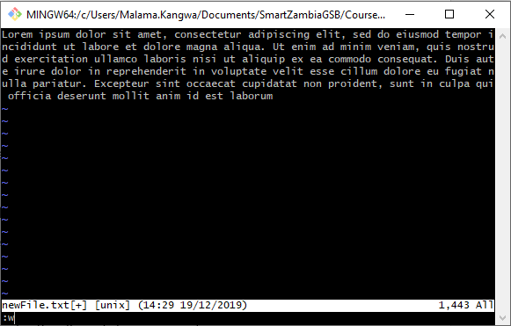

4.**:q** command closes the file.

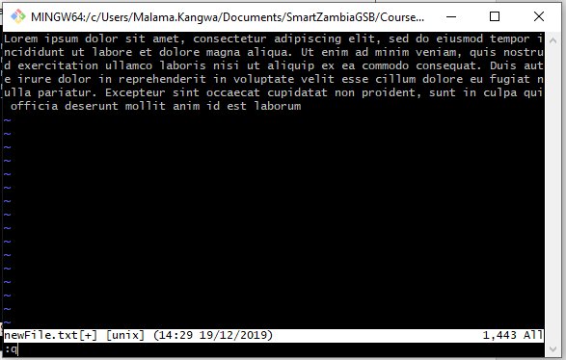

* **:wq** command saves the file before closing the file.

**:q!** command abandons changes before closing the file.

5. **0** command returns it to the first line of the paragraph.

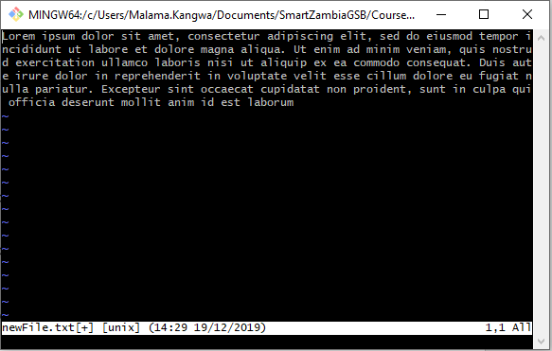

6. **o** command moves the cursor to the next line.

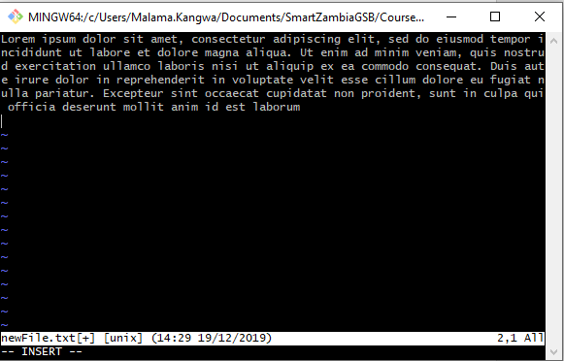

**Visual Mode** allowsyou to edit data butis more useful for dealing with chunks of data.

7.**v** command activates the --VISUAL-- mode.

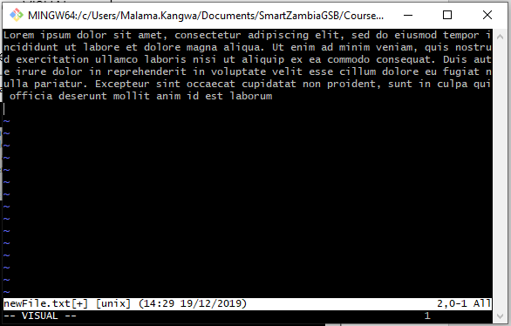

8.**y** command yanks (copies) the selected content in visual mode.

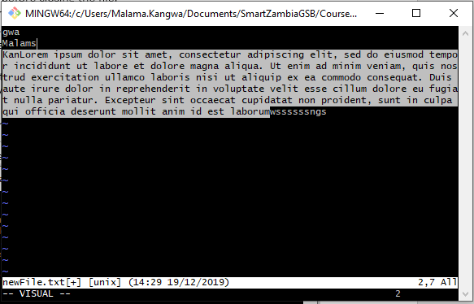

9.**d** command deletes the selected content in visual mode.

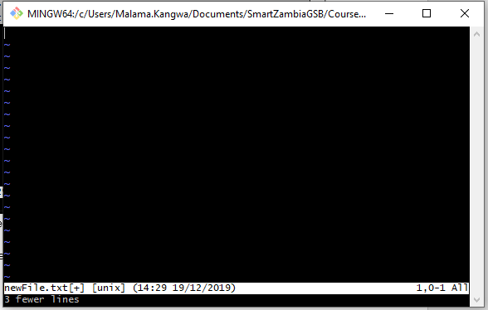

10.**p** command pastes the selected content in visual mode.

